Proposal No. 830929 Project start: 1 February 2019
Call H2020-SU-ICT-03-2018 Project duration: 47 months

D9.22
Website and Social Media Accounts 5

Document Identification
Due date | 31 December 2022
Submission date | 23 January 2023
Revision | 1.0

Related WP | WP9 | Dissemination Level | PU
Lead Participant | TDL | Lead Author | Christine Jamieson (TDL)
Contributing Beneficiaries | TDL | Related Deliverables | D9.1, D9.4, D9.9, D9.15

Abstract: This document describes the work undertaken to provide and manage the CyberSec4Europe project website and social media accounts over the lifetime of the project, and highlights the changes from the last report (D9.15) published in January 2022. It also outlines the plan for the maintenance of the site as a repository of all the project resources for the next five years following the conclusion of the project.

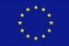
This document is issued within the CyberSec4Europe project. This project has received funding from the European Union's Horizon 2020 Programme under grant agreement no. 830929. This document and its content are the property of the CyberSec4Europe Consortium. All rights relevant to this document are determined by the applicable laws. Access to this document does not grant any right or license on the document or its contents. This document or its contents are not to be used or treated in any manner inconsistent with the rights or interests of the CyberSec4Europe Consortium and are not to be disclosed externally without prior written consent from the CyberSec4Europe Partners. Each CyberSec4Europe Partner may use this document in conformity with the CyberSec4Europe Consortium Grant Agreement provisions and the Consortium Agreement.
The information in this document is provided as is, and no warranty is given or implied that the information is fit for any particular purpose. The user thereof uses the information at its sole risk and liability.

Executive Summary
This document describes the progress of the CyberSec4Europe website over the final year of the project (2022), and is an update from the previous website and social media report, [D9.15]. The document also includes, as before, an update on the project’s social media accounts including Twitter, LinkedIn and CyberSec4Europe’s YouTube channel. The website and social media accounts continued to evolve, adapting to the latest project developments, and as a result of continuous monitoring and SEO development work. The relationship between CyberSec4Europe’s online presence and the four pilots’ joint website and social media accounts is also presented. The report highlights the additional resource that emanated from the news function which was a summary book of all the partner blog contributions over the lifetime of the project, plus plans for the maintenance of the site as a full and rich repository of the project outputs accessible to the public for the next five years.
Document information

Contributors

Name | Partner
Christine Jamieson | TDL
Romy Goodman | TDL

Reviewers

Name | Partner
Alberto Lluch Lafuente | DTU
Christos Douligeris | University of Piraeus Research Centre

History

Version | Date | Authors | Comment
0.1 | 6 December 2022 | Christine Jamieson | First draft
0.2 | 23 December 2022 | Christine Jamieson | Final Draft
1.0 | 23 January 2023 | Ahad Niknia | Final check, preparation and submission

Table of Contents
1 Introduction 1
2 Role of the website and social media 1
3 Website 1
3.1 Domain 1
3.2 Website hosting and content management system 1
3.3 Website Security 1
3.4 Overall Website Structure and Site Map 2
4 Our results 3
5 News articles 4
6 CyberSec4Europe Stories book 6
7 The European cybersecurity community 8
7.1 Our Community 8
7.2 Partners, friends and associates 8
8 Heterogeneity of data protection legislation across the EU 9
9 Promoting events 10
9.1 Event listing 10
9.2 Past Events 10
10 Website traffic 11
11 Social Media 12
11.1 Twitter 12
11.2 LinkedIn 13
11.3 YouTube 13
12 Working in collaboration with the Cyber Competence Network Communications Group 14
13 Working with DG CONNECT 14
14 Summary 16

List of Figures
Figure 1: Site map for cybersec4europe.eu 2
Figure 2: New banner head on website homepage 3
Figure 3: Home page - latest news stories 6
Figure 4: Pages from the CyberSec4Europe Stories book 8
Figure 5: Sub-brand logos for Friends and Associates 9
Figure 6: Heterogeneity of Data Protection Legislation across Europe interactive map 10
Figure 7: CyberSec4 Europe’s evening panel discussion 1 December 2022 11
Figure 8: Users and page views from 1 January 2022 to 5 December 2022 11
Figure 9: Most frequently visited pages on the website 12
Figure 10: CyberSec4Europe Twitter account 13
Figure 11: CyberSec4Europe LinkedIn statistics 13
Figure 12: CyberSec4Europe’s YouTube Channel 14
Figure 13: DG CONNECT’s newsletter article on CyberSec4Europe’s panel discussion on the Competence Centre 15
Figure 14: DG CONNECT’s newsletter article promoting CyberSec4Europe’s Insights Webinar 16
Figure 15: ECCC newsletter article promoting CyberSec4Europe’s Momentum! event 16

List of Acronyms

C | CCN | Cyber Competence Network
 | CONCORDIA | Cybersecurity Competence for Research and Innovation
E | ECCC | European Cybersecurity Competence Centre
 | ECHO | European network of Cybersecurity centres and competence Hub for innovation and Operations
 | ENISA | European Union Agency for Cybersecurity
S | SEO | Search Engine Optimisation
 | SPARTA | Strategic Programs for Advanced Research and Technology in Europe

Introduction
This report is the last of five updates on the status and progress of CyberSec4Europe’s main communication platforms, namely the project website and social media accounts (Twitter, LinkedIn and YouTube), and in parallel the website and social media accounts of the joint four pilots’ communications channels (the Cyber Competence Network website and Twitter account). It examines what developments have occurred over the last 11 months (during 2022, since the publication of deliverable D9.15), what their impact has been and how overall the channels are performing.

Role of the website and social media
The website and social media accounts are the major communication channels of CyberSec4Europe for the dissemination of results and project activities to its stakeholder community. Specifically, they act as an information platform for Members of the European Parliament, the European Commission, ENISA, ECSO and the other three pilots (SPARTA, ECHO and CONCORDIA). In particular the COVID-19 crisis between 2020 and 2021 demonstrated the critical importance of these online tools as the project’s “shop window” in the absence of face-to-face meetings. The ‘normalisation’ of virtual meetings in the light of the pandemic offered the website an opportunity to record and post content of all online and hybrid events of the project, which we now have for posterity.

Website

Domain
The cybersec4europe.eu domain, acquired in May 2018, continues to be the one used by the project and there are no plans to take up any similar domains, although other similar sounding domains were acquired to avoid potential confusion and will now be discontinued.

Website hosting and content management system
The project website https://cybersec4europe.eu was first published on 18 February 2019, relaunched in November 2019 with a completely new design and has been regularly updated since. In January 2022 the site moved to a new hosting provider, Cloudways, a leading WordPress hosting provider, and is now hosted on WordPress 6.1.1 via Cloudways on Digital Ocean in an Amsterdam data centre. The reason for the transfer was that the previous hosting provider, Flywheel, now owned by WP Engine, moved all their sites to Google Cloud which immediately reduced performance with unattractive accompanying support conditions. The difference in speed, reliability and scaling with Cloudways is very noticeable.

Website Security
In addition to the Cloudways security assurances, the CyberSec4Europe site is monitored via ManageWP, a monitoring and maintenance dashboard, which is set to provide alerts if the site goes offline or there are any unpatched vulnerabilities. Full automatically updated privacy and cookie policies are provided via iubenda.com and visitors’ IP addresses are anonymised for the purposes of Google Analytics. The website is GDPR compliant.

Overall Website Structure and Site Map
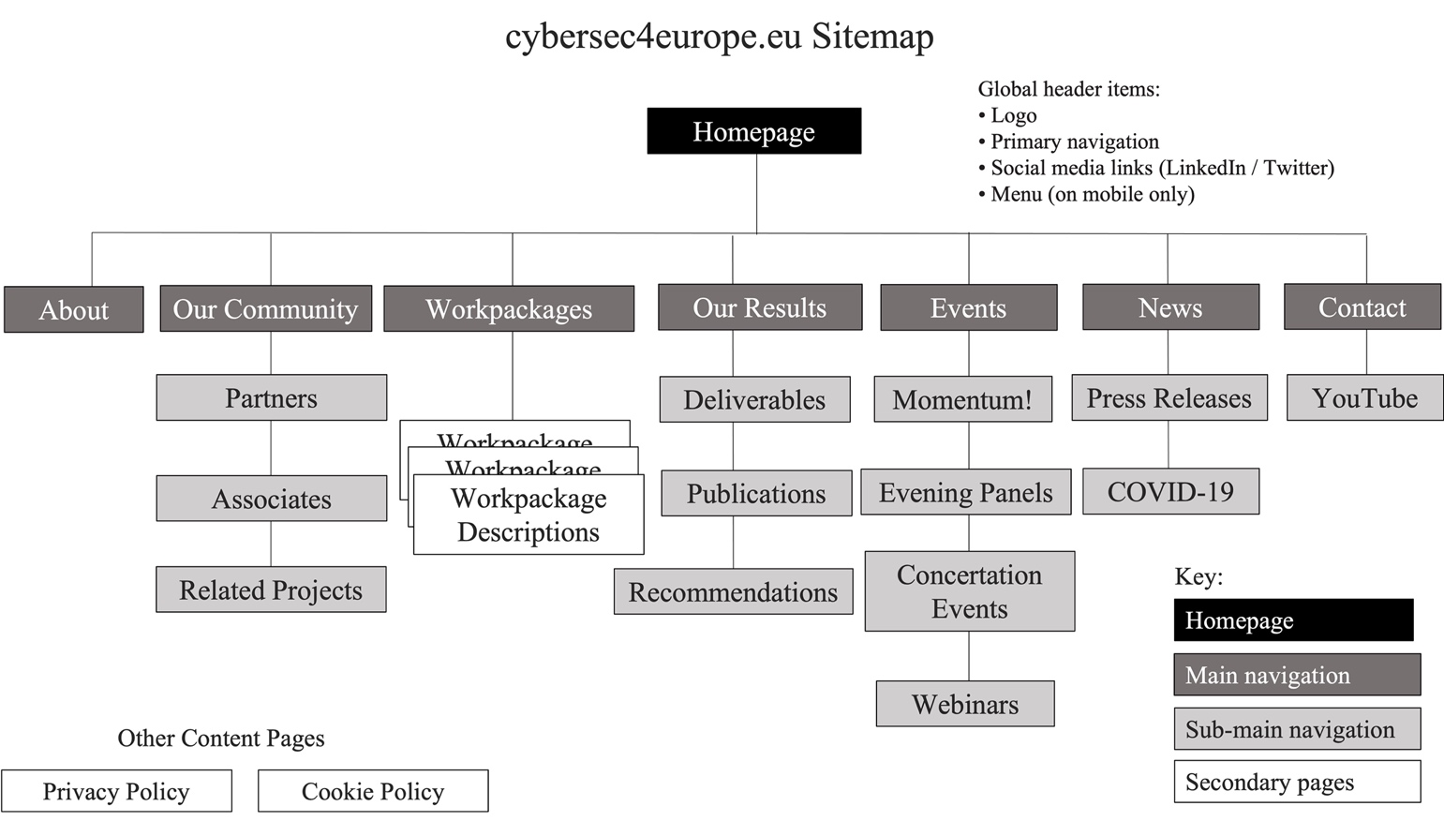
Figure 1: Site map for cybersec4europe.eu
At a high level, the website is divided into the following sections, reachable via the main menu of the homepage (see Figure 1):
    - Homepage
The main landing page where visitors usually arrive, providing an overview of the project and its aims and objectives, as well as all the latest news items and upcoming events. On occasion of project high profile events it has employed the main masthead as a large banner advertisement for the events, linking to an information and registration page. The Homepage is where site visitors can easily access both the latest news blogs and social media postings.
    - About
An overview of the high-level goals of CyberSec4Europe, including the project’s policy, technical and innovation objectives.
    - Our Community
An overview of the European cybersecurity stakeholder community, described more fully below (see section 5).
    - Work Packages
Details about the project’s internal structuring and the goals of the different parts of the project. It contains two series of video interviews in which work package leaders discuss the progress of their tasks over the lifetime of the project and what they see as the challenges going forward. The second of these was filmed remotely due to COVID-19 restrictions.
- Our Results
Demonstrates the work carried out and delivered by the project, including all completed deliverables, publications and latest results. CyberSec4Europe publishes all of its public project deliverables which are available for download. Those deliverables not yet formally reviewed or accepted are marked with*
    - Events
Information about all planned, current and past events (co-)organised, supported or attended by CyberSec4Europe or its partners. (see section 6). This part of the site has a further section devoted to the CyberSec4Europe Insights series of webinars (see section 8) as well as details of the three concertation and “Momentum!” events.
    - News
A summary and archive of all the project news articles, press releases and announcements. (see section 4). This heading on the site also contains the specially created COVID-19 update page, which was carefully maintained throughout 2020-21, although it is no longer highlighted from the home page.
    - Contact
A form for visitors to complete to receive regular news updates (see section 6.2). This section also contains a link to the project YouTube channel.
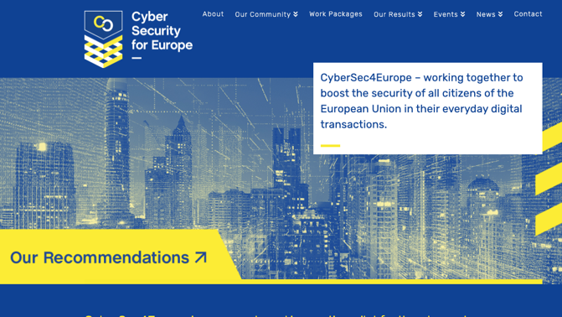
Figure 2: New banner head on website homepage

Our results
This heading collects in one place all the formal output from the project beneficiaries:
    - Deliverables
Lists the project deliverables once they have been submitted to the Commission and are freely available for on-screen browsing or download. The only deliverables that are not listed are the management reports from work package (WP1) which are marked confidential.
    - Publications
Lists over 150 publications generated within the project, ranging from academic papers to conference procedings, all authored or co-authored by consortium partners. This section will also serve as a one-stop shop for all generated publications after the end of the project.
    - Latest Results
Introduced to provide a showcase for participants in each project activity to present their work in a distinctive manner of their own choosing. This section contains, in addition to the deliverables that CyberSec4Europe partners produced, more results emerging from the project that are either not available or supplement what is in the deliverable reports. These include the software assets from Blueprint Design and Common Research (WP3) according to the individual WP3 tasks with links to more technical entries in GitHub; and detailed descriptions and downloads of the tools in the Open Tool Portal (WP7)
    - Recommendations
For the final year of the project, we turned the headline focus on the website to the project’s recommendations for the future. A new link to a summary of the current recommendations is prominently sign-posted directly from the homepage on the main banner head (see Figure 2). The project has published seven policy recommendations on a variety of topics (at the time of writing), which will be available as downloadable CyberSec4Europe policy briefs.

News articles
Since its launch we have maintained a content-rich and varied news page, highlighting the many aspects of project partners’ work including highlights of most of the deliverables for easy access. The stories are thoroughly edited by native English language speakers to ensure that they are accessible not only to cybersecurity professionals but also to a broader audience such as legislators, educators, media and the general public. The breadth of news stories mirrors the wide number of activities that project partners are immersed in (Figure 3). In addition to “news” content about the project there are also several opinion pieces about current debates within the cybersecurity arena. The following stories have featured over the last year (2022):
January
Proactive Approaches For Secure Software Development
Advances in Usable Security
Don’t Miss the Privacy Symposium 2022 in Venice!

February
Demonstrating The Application And Usability Of Security And Privacy Software Assets
Upcoming Event: Benefits And Risks Of Emerging Technologies And The GDPR

March
Preparing The Second Round Of Commercial And Application Demonstrators
Flagship 2: The Successful Second Cybersecurity Exercise Hosted By CyberSec4Europe
The Vital Importance Of Blue Sky Research in Cybersecurity

April
Making Cybersecurity Standards More Accessible
Introducing SURFACE – A Support Framework For Certification

May
CyberSec4Europe In Venice

June
CONVERGENCE NEXT Is Here!
Multidisciplinary Approach in Cybersecurity Awareness
CyberSec4Europe – Open Tool Portal

July
The European Cybersecurity Competence Centre: Governing Board Meets In Person For The First Time In Bucharest

August
Burning Down The House
Future Research Challenges in Cybersecurity for European Digital Sovereignty

September
What Can Member States Expect From Their Cybersecurity Communities?
A Recommendation To Support Research In Password-less Authentication
The EU Cybersecurity Skill Gap Is Bleeding – But You Can Help Heal It!

October
Learning More About Cyber4SecEurope Scientific Publications
Momentum!
Reasonable Security
Review And Reflections On Maritime Transport

November
Momentum!
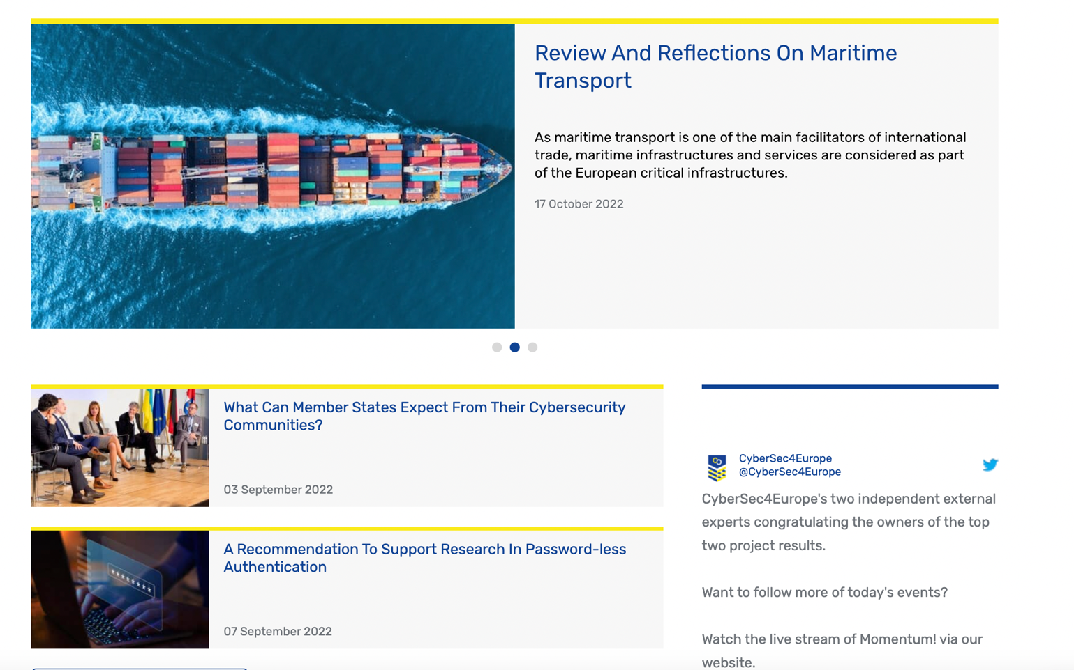
Figure 3: Home page - latest news stories

CyberSec4Europe Stories book
The collection of news blogs that were published on the website over the last four years give the outline narrative of CyberSec4Europe. As such it was decided that a hard copy publication could be derived from these contributions, which would describe the different approaches to each subject area, the breadth of research and the creativity of the partners and ultimately to highlight the project's many achievements. This book was designed to be a comprehensive narrative accessible to a wide audience beyond the technical community. Hence care was taken to ensure that the often complex concepts were described in as approachable a way as possible to get the attention of the broader non-technical community to incentivise them to explore some of the more technical source material contained in the project deliverables. Additionally, the various ‘opinion pieces’ were also included in the book to give voice to the many unique contributors from the 43 partner institutions.

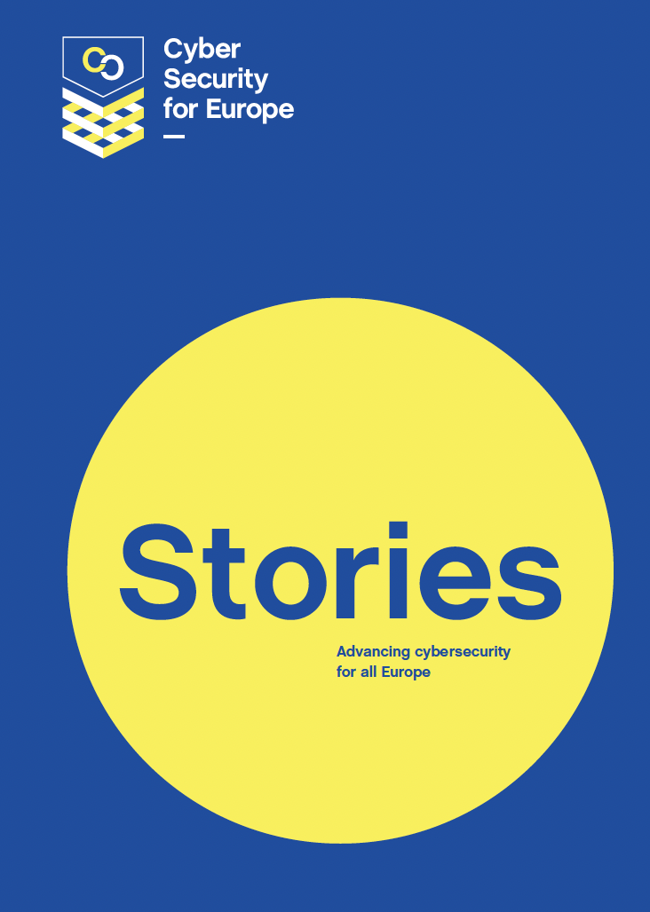

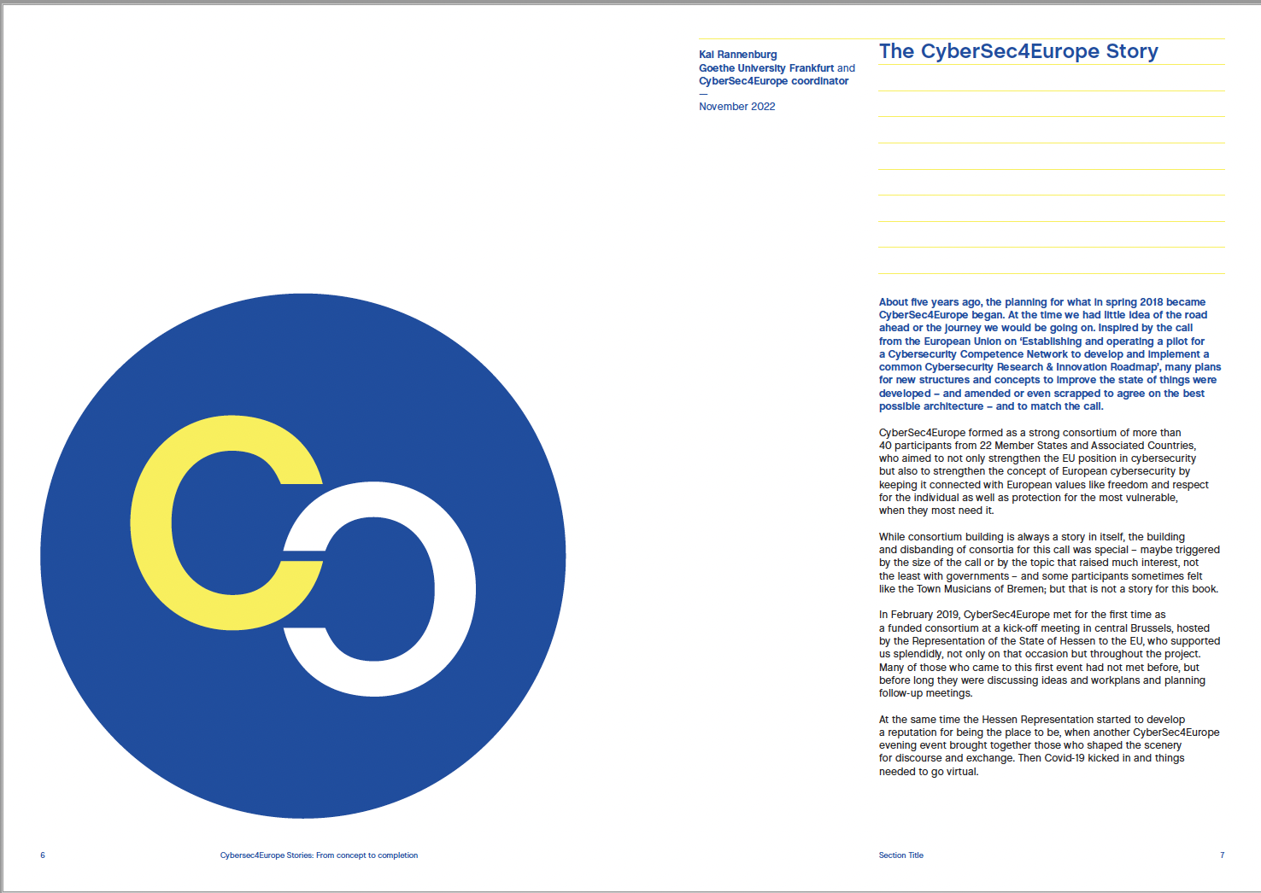
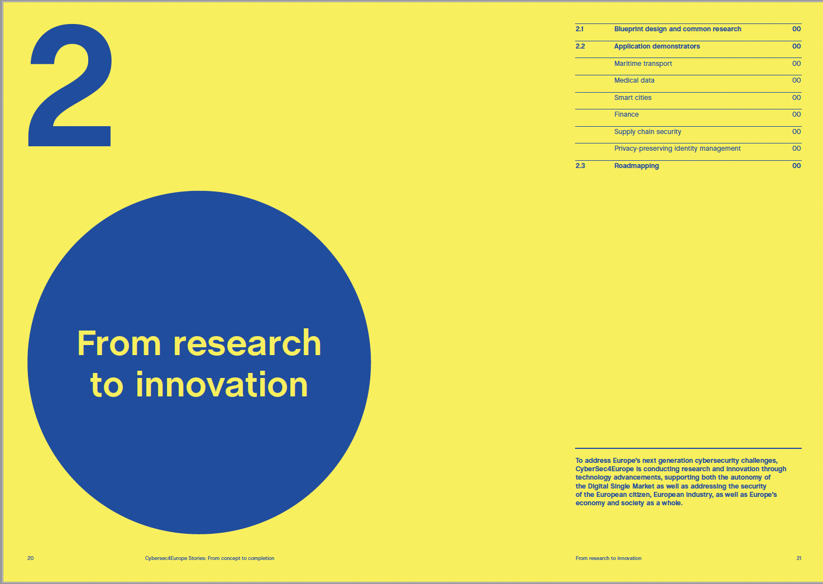
Figure 4: Pages from the CyberSec4Europe Stories book

The European cybersecurity community

Our Community
The Our Community page was completely restructured and re-written during the course of the project to give a comprehensive overview of the overall cybersecurity landscape across Europe. It features the following sections:
- Cybersecurity Competence Centre and Network
- The European Cybersecurity Competence Centre
- Network of National Coordination Centres
- The Cybersecurity Competence Community
- The Four Pilot Projects
- Cybersecurity Atlas
- CyberSec4Europe Partners
- CyberSec4Europe Associates
- Friends of CyberSec4Europe
A fulsome description of the structure of the European Cybersecurity Competence Centre has been set out which helpfully describes the tasks and objectives of the Centre and explains the governance structure.

Partners, friends and associates
The project’s 43 partners can be found listed on the Partners page, which is a sub-domain of Our Community in addition to the ‘Associate Partners’ and the ‘Friends of CyberSec4Europe’ - both with their own distinctive sub-brands (see Figure 5).
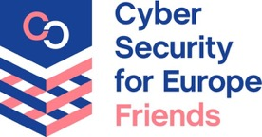
Figure 5: Sub-brand logos for Friends and Associates
Someone wishing to become a 'Friend of CyberSec4Europe' can subscribe, via the website, to a project update news service. In 2022 eight news updates were mailed to our network of over 40 Associate partners and 13 to more than 160 Friends.

Heterogeneity of data protection legislation across the EU
The website also features an interactive map (see Figure 6) which is based on the results of a survey carried out by the project, collating feedback from 19 Member States (Austria, Belgium, Croatia, Cyprus, Czechia, Denmark, Estonia, Finland, Greece, Germany, Hungary, Latvia, Luxembourg, Malta, Poland, Romania, Slovakia, Slovenia, and Spain) between April 2020 and May 2021.
The feedback was combined into a map of Europe containing the data collected from the national supervisory authorities (at the top of the page). The map allows a quick overview of the results of the survey, where a country coloured yellow indicates that a Member State has a particular rule or legislation on a selected topic and coloured blue means they do not. One can move between topics by selecting the chosen topic under the map. The topics “Other Legislation” and the existence of laws that “Extend the GDPR” are a little different in that the colour of the map only tells the viewer if there is any additional legislation or extension: for further details, one has to hover over the Member State for more expanded information (see Figure 5).

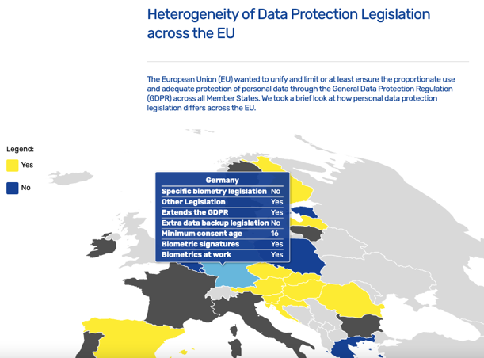
Figure 6: Heterogeneity of Data Protection Legislation across Europe interactive map

Promoting events
The website continues to play an essential role in promoting events by reaching out to a wide audience, as well as raising awareness of CyberSec4Europe partner participation in cybersecurity-related conferences and summer schools.

Event listing
There is a full event listing section on the site (https://cybersec4europe.eu/events) which, apart from highlighting all CyberSec4Europe events, also contains a useful listing of many other forthcoming cybersecurity-related events that project partners are actively involved in, including links to the websites of the events themselves. Reports of all past events are also featured in this section for historical record.

Past Events
All CyberSec4Europe hosted events, which were held remotely or in hybrid form because of the pandemic, were uploaded on to the website.
The 2022 evening panel discussions which featured a variety of invited cybersecurity experts including representatives from the three major European institutions and the newly formed ECCC, were:
- Benefits and risks of emerging technologies and the GDPR (16 February)
- The European Cybersecurity Competence Centre (ECCC) (1 June)
- What can Member States expect of their cybersecurity communities (15 September)
- Cybersecurity in Europe: Past, Present and Future (1 December)

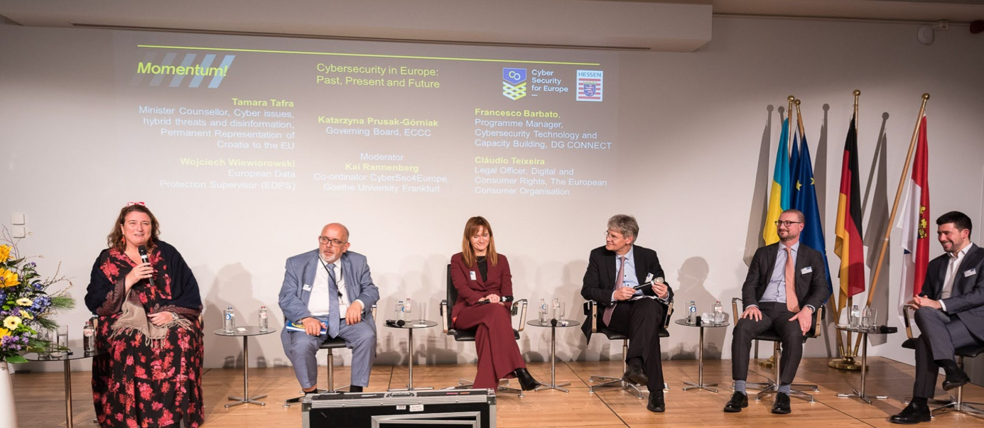
Figure 7: CyberSec4 Europe’s evening panel discussion 1 December 2022

CyberSec4Europe Insights
Insights, launched in December 2020, was a series of broadcasts and webinars relating to different topics associated with cybersecurity and the work of the project. We hosted five such webinars in 2020-21 and the recordings of all of these have been uploaded on to the website.

Website traffic
Since the last report, the website traffic has continued with a steady flow of site visits and an increase in new visitors. We have consistently hyperlinked Twitter and LinkedIn to the website for more information on events, blogs and general news. We logged 13,012 visitors to the site during 2022, of which 12,942 were new users (see Figures 8 and 9).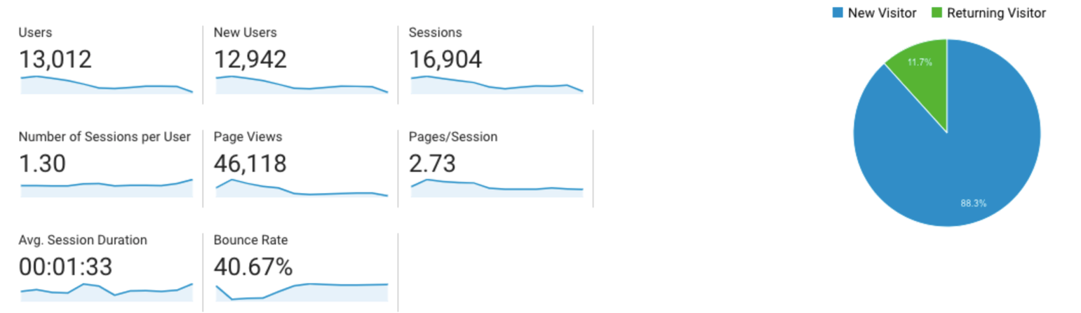

Figure 8: Users and page views from 1 January 2022 to 5 December 2022

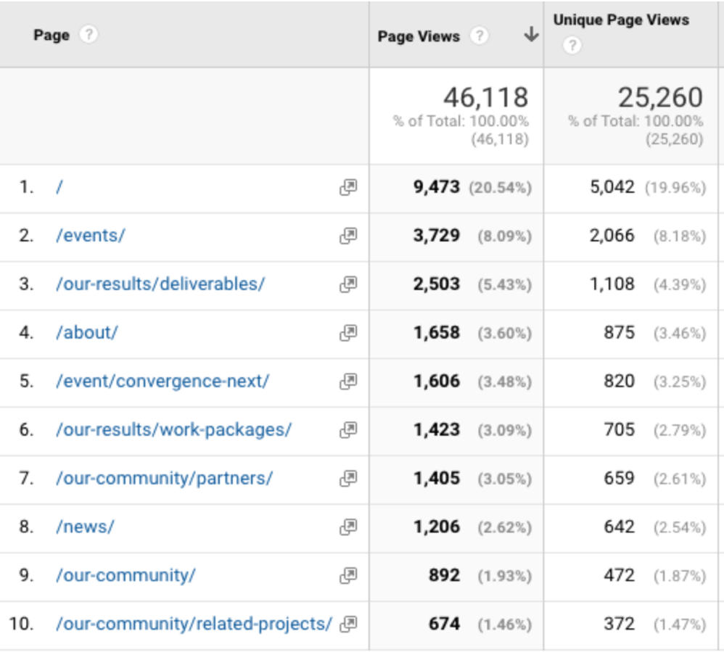
Figure 9: Most frequently visited pages on the website
Since October 2020, we have continued to use Yoast software on the website to enhance our search engine optimisation (SEO) on each news posting and also, across all the content of the website, to further increase our visibility on the Internet. The increase in visitors over the last two years confirms that this approach has been successful.

Social Media

Twitter
The number of followers of the CyberSec4Europe Twitter account (@CyberSec4Europe) has steadily increased year on year (13% over 2022) with our consistent tweets, and retweets from related accounts, to push our reach further into the community and bring more awareness of the project. We have continued to use personalised images and GIFs to further establish the project brand. With nearly every posting having a link to our website, our Twitter platform has been helpful in directing people’s attention towards the work we’re doing, giving them the opportunity to access and download project deliverables.

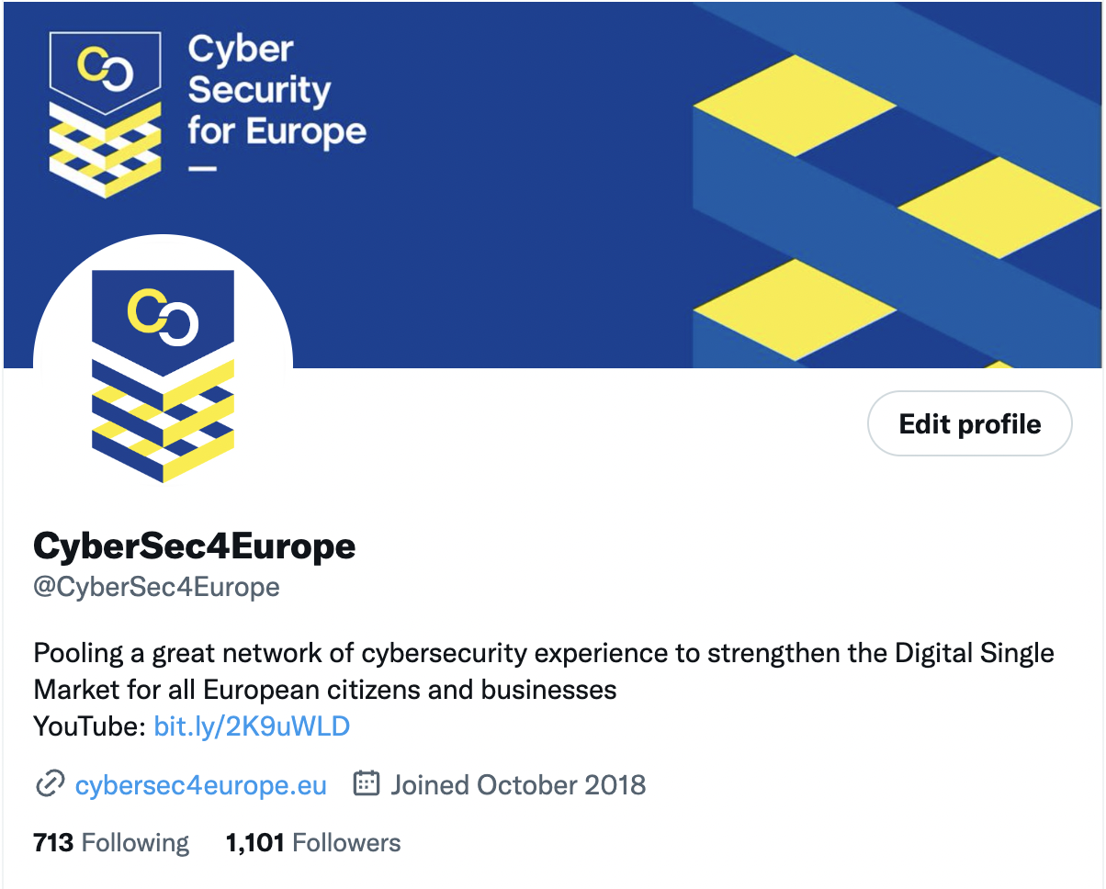
Figure 10: CyberSec4Europe Twitter account

LinkedIn
Our LinkedIn account is used to re-post all of our current news stories as mini-blogs and continued to attract a healthy number of new followers each month. There is a steady flow of visitors via laptop or mobile device to our account.
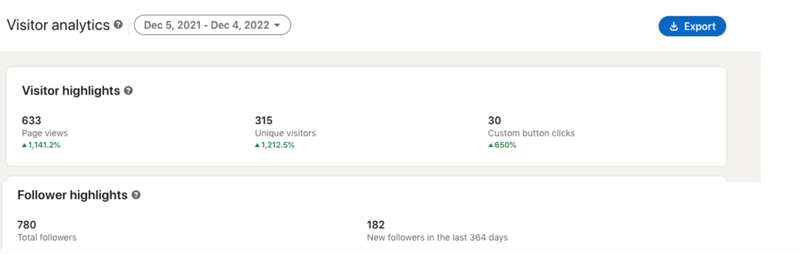
Figure 11: CyberSec4Europe LinkedIn statistics

YouTube
CyberSec4Europe’s YouTube channel contains a rich resource of material from across all the events that the project has hosted. As many of these were virtual events, it has been particularly important to capture them for posterity. Working within the constraints of filming remotely, we have produced more records of events on a diverse range of topics. Teaser and tutorial videos of the assets of WP3 are also featured on the channels as well. We aimed to keep the content relevant and up to date at all times. The procedings of the two major events of 2022 – CONVERGENCE NEXT and Momentum! are available on the YouTube channel.
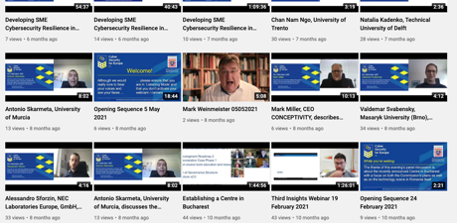
Figure 12: CyberSec4Europe’s YouTube Channel

Working in collaboration with the Cyber Competence Network Communications Group
CyberSec4Europe continued during the first half of 2022 to actively contribute to the various communications activities with our fellow pilots and promote the Cyber Competence Network (CCN) brand whilst all four groups were running in parallel.
CyberSec4Europe on behalf of the four pilots was chosen to moderate the presentations given all day every day in the pitch area of the EU Pavillion at FIC 2022 from 7-9 June 2022 at the Grand Palais Lille.
The work of this group is all detailed in its website – www.cybercompetencenetwork.eu which CyberSec4Europe has regularly contributed to and helped manage its content. In June 2021 the Group produced a common four pilots’ presentation, available on the website, that could be presented by any CCN representative on behalf of all the projects. In addition to the website there is also an active Twitter presence which has over the course of 2022 reached 586 followers.
The four pilots’ Communications Group met regularly online during the lifetime of the respective projects. CyberSec4Europe took over chairing this group from July 2022.

Working with DG CONNECT
CyberSec4Europe also regularly contributed to DG CONNECT and more recently the ECCC monthly cybersecurity newsletter with stories highlighting aspects of our work and events. The project has also benefitted from the participation of project officers and the head of unit from DG CONNECT at the project’s evening panel discussions.
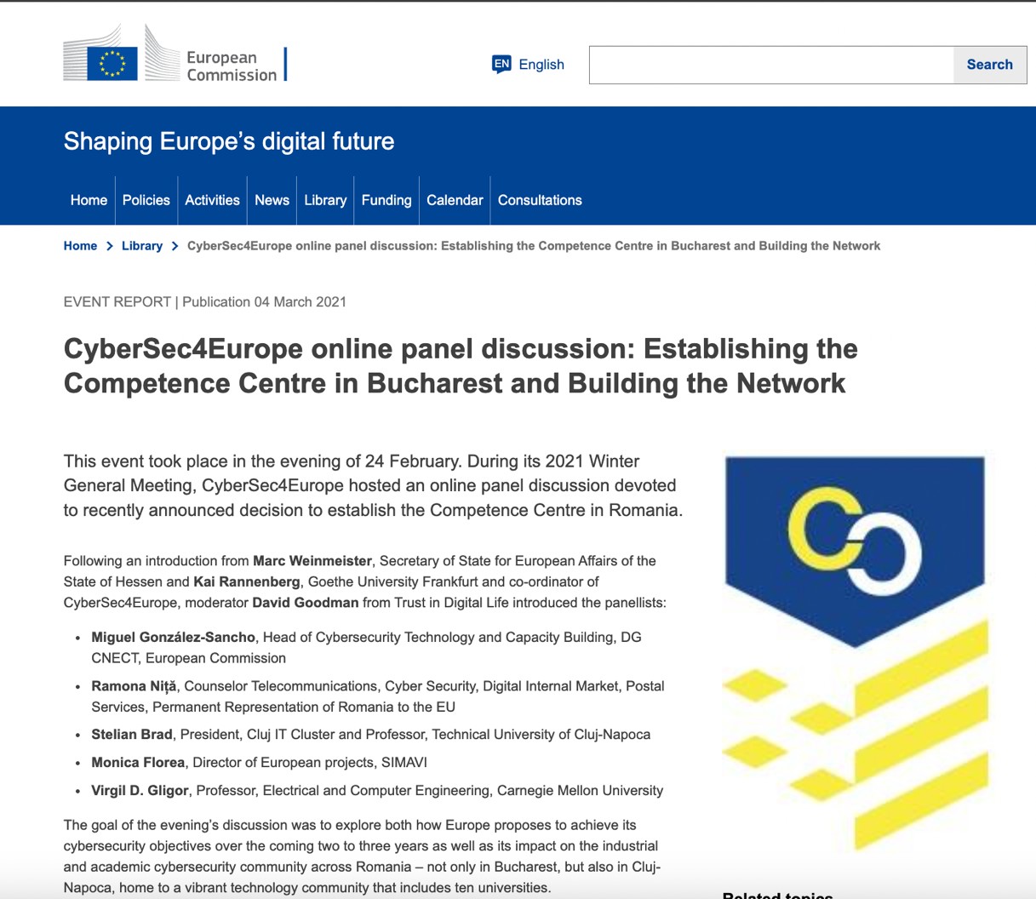

Figure 13: DG CONNECT’s newsletter article on CyberSec4Europe’s panel discussion on the Competence Centre
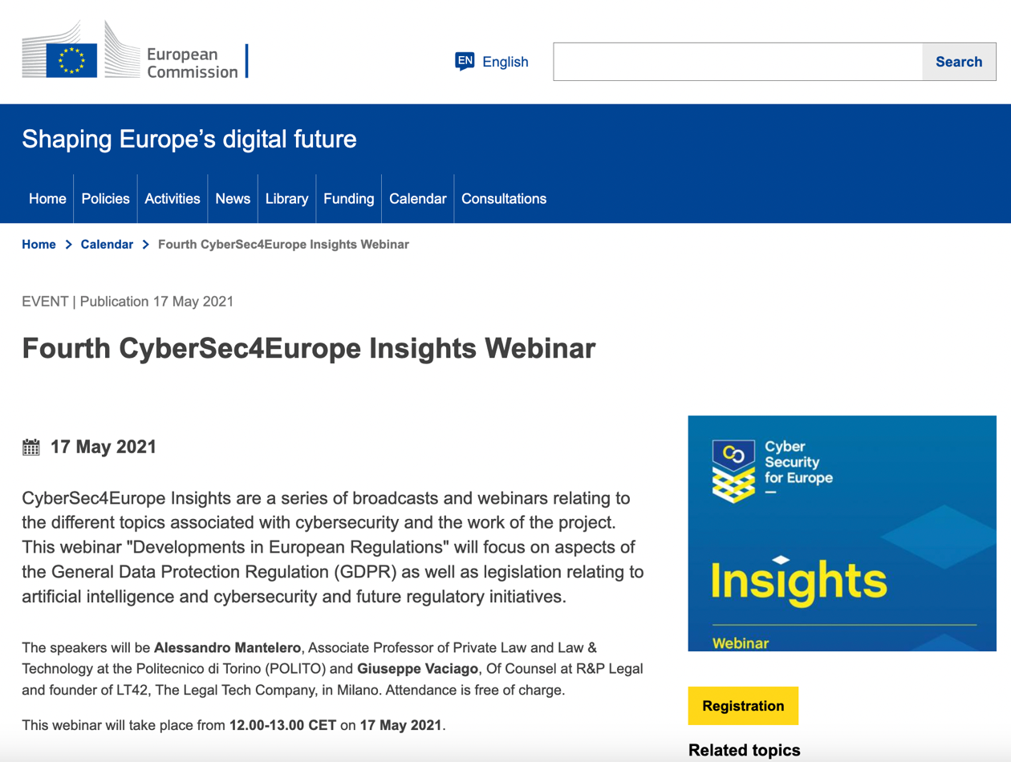
Figure 14: DG CONNECT’s newsletter article promoting CyberSec4Europe’s Insights Webinar
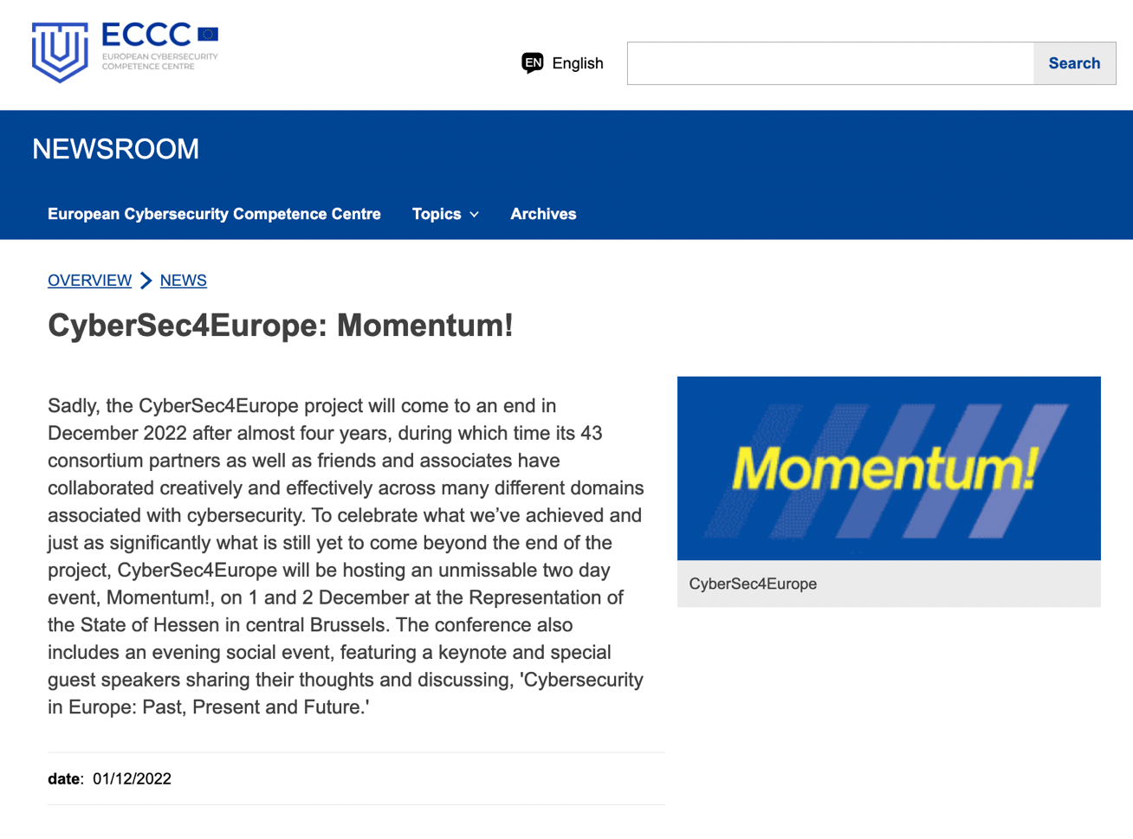
Figure 15: ECCC newsletter article promoting CyberSec4Europe’s Momentum! event

Summary
The work to promote the CyberSec4Europe project will continue almost daily through the various channels, to the end of this year. The ambition to keep expanding the website so that it is a lively, engaging and relevant resource, that will have a life beyond the scope of the project, continues apace. News stories that highlight the deliverables that the project has recently completed are continually posted and linked through social media channels to reach intended audiences and beyond. As mentioned earlier in this report, during this final period of the project the website has started to reflect the legacy achievements of CyberSec4Europe, through its Recommendations page and Exploitation page so that visitors to the site can understand what the project has accomplished over its lifetime, its specific recommendations, its key exploitable assets, its publications and deliverable reports and what the future significance of its work will be.
The website will continue to be live for five years (at the same domain) from the end of project funding at the end of 2022, and we hope it will prove to be a fitting reflection of everything that CyberSec4Europe has achieved during the course of the last four years.

